GROUP MEMBERS
ST10303074
RICHARD SIBOMANA

Group 6 Research
OPSC6311

Contents
Introduction 2
1. Goodbudget 2
Overview 2
Strengths and Weaknesses 2
Innovative Features 3
2. Spendee 3
Overview 3
Strengths and Weaknesses 4
Innovative Features 5
3. Money Lover 5
Overview 5
Strengths and Weaknesses 6
Innovative Features 6
Infographic Comparison of Apps 6
Best Features for Inclusion in the Personal Budget Tracker App 7
Conclusion 7
References 8

Introduction
Managing your personal finances can have a HUGE impact on your financial stability and well-being. Digital solutions have sky-rocketed and it’s now common for budgeting apps to assist users in tracking spending, establishing savings goals and creating positive habits along the way. For people who are not financially disciplined, using a well-designed budgeting app can be much easier and more fun than managing money with pen and paper.
The purpose of this study is to evaluate three personal budgeting applications that are currently available for the Android operating system. An outline of each app's advantages and disadvantages as well as its novel features will be part of the analysis. To highlight the main distinctions and parallels between the chosen apps, a comparative infographic will be supplied. Lastly, it will be decided which of these apps' best features could be incorporated into the suggested Personal Budget Tracker app.

1. Goodbudget

Overview
Goodbudget, Envelope Budgeting App Users can have their income divided into virtual envelopes, giving them control over their spending limits for different types of purchases. The app is made for individuals as well as families who want their finances in order. Goodbudget doesn’t sync with bank accounts like typical banking apps, so users must enter their transactions manually. (Good Budget, 2009)
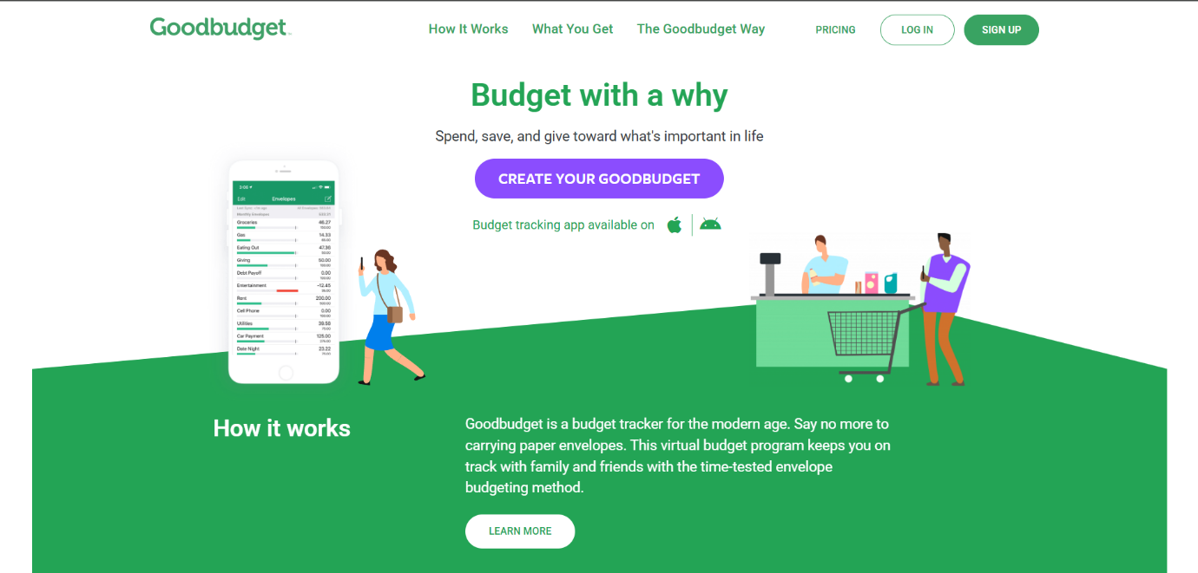
Goodbudget opens with a clean and straightforward layout, making it easy for users to start using to manage their finances. On the main page, you'll find an introduction to the envelope budgeting method, which explains how you can allocate your money into virtual envelopes for various spending categories. Just below that, you have the choice to either sign in to your existing account or create a new one. A quick summary showcases key features like budget tracking, debt management, and syncing family accounts. The design is minimalistic, focusing on helping new users grasp the app’s purpose before they sign up.

Strengths and Weaknesses
Strengths:
• It syncs across multiple devices, which makes family budgeting easy.
• It offers tools for tracking expenses and setting spending limits.
• It has a debt tracking features to help users manage their repayments.
• It provides detailed spending reports that allow users to analyse their finances efficiently.
Weaknesses:
• You must manually input transactions, which takes a lot of time.
• There’s no option for automatic bank account syncing.
• You need to subscribe to get all the features.
• It doesn’t have the investment tracking features that other financial apps offer.

Innovative Features
• A virtual envelope budgeting system to help you stay on top of your finances.
• Syncing across multiple devices to make family budgeting easy.
• Features for tracking debt and setting financial goals.
• Spending reports and breakdowns for clearer insights.
• The option to export your financial data for further analysis.

2. Spendee

Overview
Spendee is a budgeting app that helps you keep an eye on your spending, set budgets and understand your finances. It even syncs with your bank account for automatic transaction updates and allows for shared wallets, making group budgeting easy. Spendee makes it simple to see your financial habits due to its user friendly interface. (Spendee, 2017)
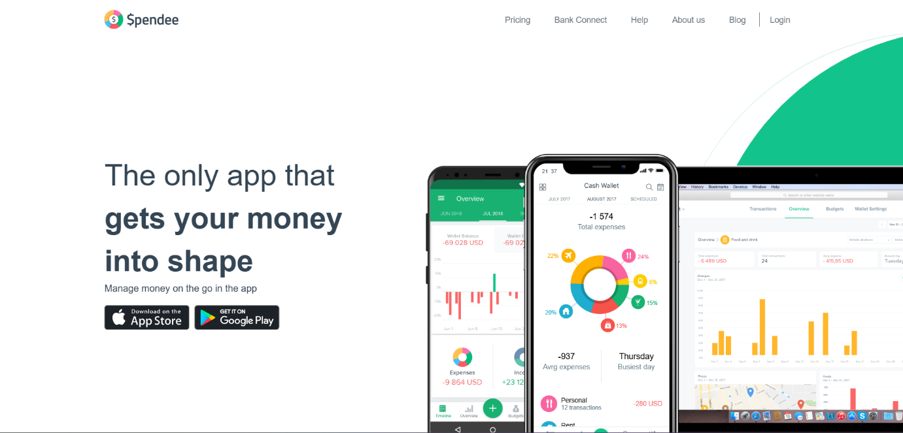
The app opens with its logo and then it takes you to an introduction page that lays out its main features, like automatic expense tracking, budget management and shared wallets. Right below that, you can either sign in or set up a new account. There’s also preview images that highlight the app’s standout features, such as bank synchronization, spending insights and financial charts.

Strengths and Weaknesses
Strengths:
• User-friendly UI design.
• Automatically tracks transactions by syncing with your bank accounts.
• Lets you create shared wallets for collaborative budgeting.
• Supports various currencies, making it ideal for the users that are traveling.
• Provides analytics for your spending habits.
• Gives you a financial health score to help you evaluate how well you’re managing your budget.
Weaknesses:
- You need to subscribe to access al features.
- The financial planning tools are a bit limited compared to other budgeting apps.
- Bank synchronisation is not available everywhere.
- Syncing to bank transactions is slow.

Innovative Features
• Shared wallets to help manage finances as a group.
• Visual tools that make financial analysis easy.
• A financial health score to show users how they are spending money.
• AI-powered insights that help you develop better budgeting habits.

3. Money Lover

Overview
Money Lover is an all-in-one budgeting app designed to help you keep tabs on your spending, create budgets, and achieve your financial goals. It offers features like bill reminders, spending insights and savings goal tracking, making it easier for you to manage your finances. Money Lover can also link multiple accounts and automatically categorize your expenses. (Money Lover, 2012)
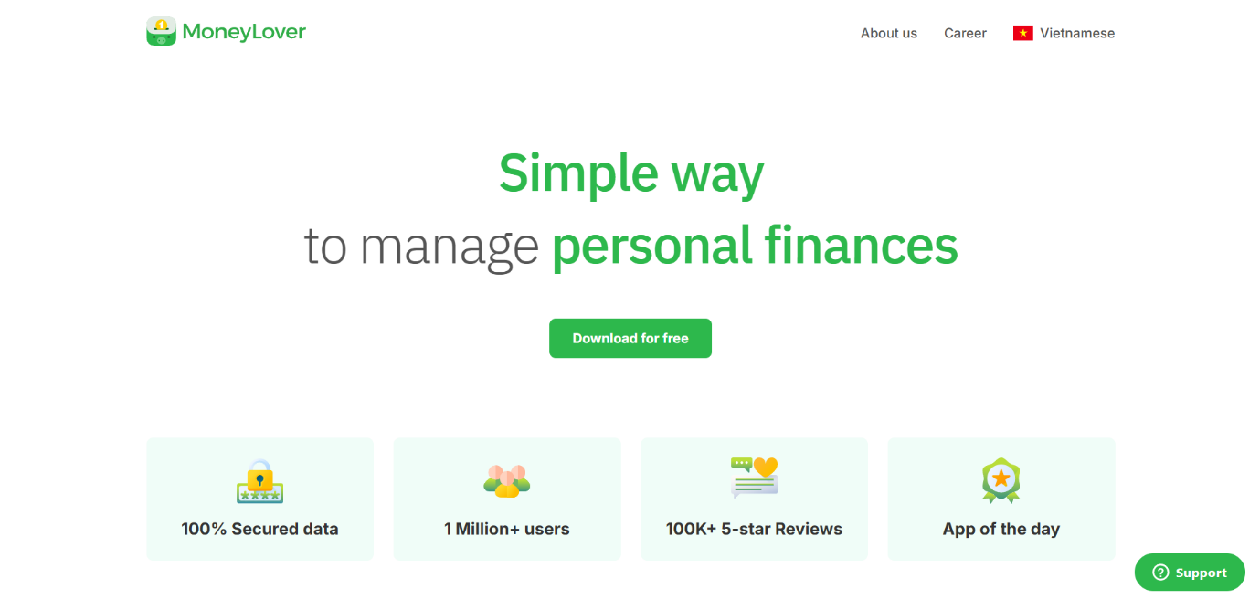

When you first launch Money Lover, the home screen gives you a quick overview of what the app can do. The interface has an introduction section that shows you through how to use the app. Just below that, you’ll find options to log in or create a new account. The app practically invites users to try out the app before they decide to sign up.

Strengths and Weaknesses
Strengths:
• Sends you reminders for bills so you never miss a payment.
• Works on multiple platforms, such as Android, iOS, web and desktop.
• Integrates with digital wallets for effortless transaction tracking.
• Supports various accounts, from bank accounts to credit cards and even cash.
• Features predictive budgeting tools to help you foresee future expenses.
Weaknesses:
• You need a subscription to access all features.
• The free version has some restrictions when it comes to tracking multiple accounts.
• The free version has ads.
• Some users have mentioned experiencing occasional syncing problems with their bank accounts.

Innovative Features
• Track your expenses easily because of the categories section which you can customize to fit your needs.
• A budget forecast based on your previous spending habits.
• Secur data backup through cloud storage integration.

Infographic Comparison of Apps

Feature | Goodbudget | Spendee | Money Lover
Budgeting System | Envelope budgeting | Traditional budgeting with insights | AI-powered predictive budgeting
Bank Sync | ❌ Manual entry only | ✅ Yes | ✅ Yes
Shared Budgeting | ✅ multi-device sync | ✅ Shared wallets | ❌ Not available
Expense Tracking | ✅ Manual tracking | ✅ Automatic sync | ✅ Automatic sync & categorization
Bill Reminders | ❌ No | ❌ No | ✅ Yes
Visual Reports | ✅ Spending graphs | ✅ Colourful insights | ✅ Detailed reports & AI analysis
Multi-Currency Support | ❌ No | ✅ Yes | ✅ Yes
Colour: ✅ in green and weaknesses ❌ in red for easy readability.

Best Features for Inclusion in the Personal Budget Tracker App
Based on the analysis of the three budgeting apps, the following features have been identified as desirable for inclusion in the proposed Personal Budget Tracker app:
- Envelope Budgeting System (Goodbudget) – Helps users allocate funds into different spending categories effectively.
- Financial Goal Tracking (Money Lover) – Enables users to set and track progress toward savings goals.
- Bill Reminders (Money Lover) – Helps users keep up with recurring payments.
- Data Visualization & Reports – Provides graphs and insights to help users analyse spending trends.
- Smart Notifications & Alerts – Ensures users stay on track with budgeting and financial goals.
- Gamification Elements – Rewards users for consistent budgeting habits and meeting financial goals.

Conclusion
This research dives deep into three well-known personal budgeting apps—Goodbudget, Spendee and Money Lover. Each of these apps brings something special to the table, enhancing financial management and keeping users engaged. By blending the best features from these apps, our proposed Personal Budget Tracker app aims to offer users a seamless, user-friendly and enjoyable way to handle their finances. Adding elements of gamification, automated tracking and data visualization will transform budgeting into a fun and rewarding experience. The next step in our project will be to plan and design the app using these valuable insights.

References
Good Budget. (2009). Good Budget. Retrieved from goodbudget.com: https://goodbudget.com/
Money Lover. (2012). Money Lover. Retrieved from moneylover.me: https://moneylover.me/
Spendee. (2017). Spendee. Retrieved from www.spendee.com: https://www.spendee.com/

